Conceptual model of
Fixed assets management system

Version 0.0

Students:
19522467 – Le Thanh Tuan
19520358 – Pham Hieu Vy
19522455- Phung Thanh Tu
Document change record sheet

Date | Version | Description | Authors
25/10/2021 | 0.0 | Initial document. | Phung Thanh Tu, Le Thanh Tuan and Pham Hieu Vy co-operated.
1/11/2021 | 0.1 | Analysis Level of the document | Phung Thanh Tu, Le Thanh Tuan and Pham Hieu Vy co-operated.

Table of contents

1. Class diagram (analysis/conceptual level) 3
1.1 Class diagram (analysis level) 3
1.2 List of classes and relationships in Database Module 3
1.3 List of classes and relationships in UI Module and Login Module 4
2. Cohesion and coupling 4
3. State machine diagram (2-3 diagrams) 4

Class diagram (analysis/conceptual level)

Class diagram (analysis level)
Due to the high complexity of this diagram, I don’t show the analysis level of the class diagram. Updates will be made later.
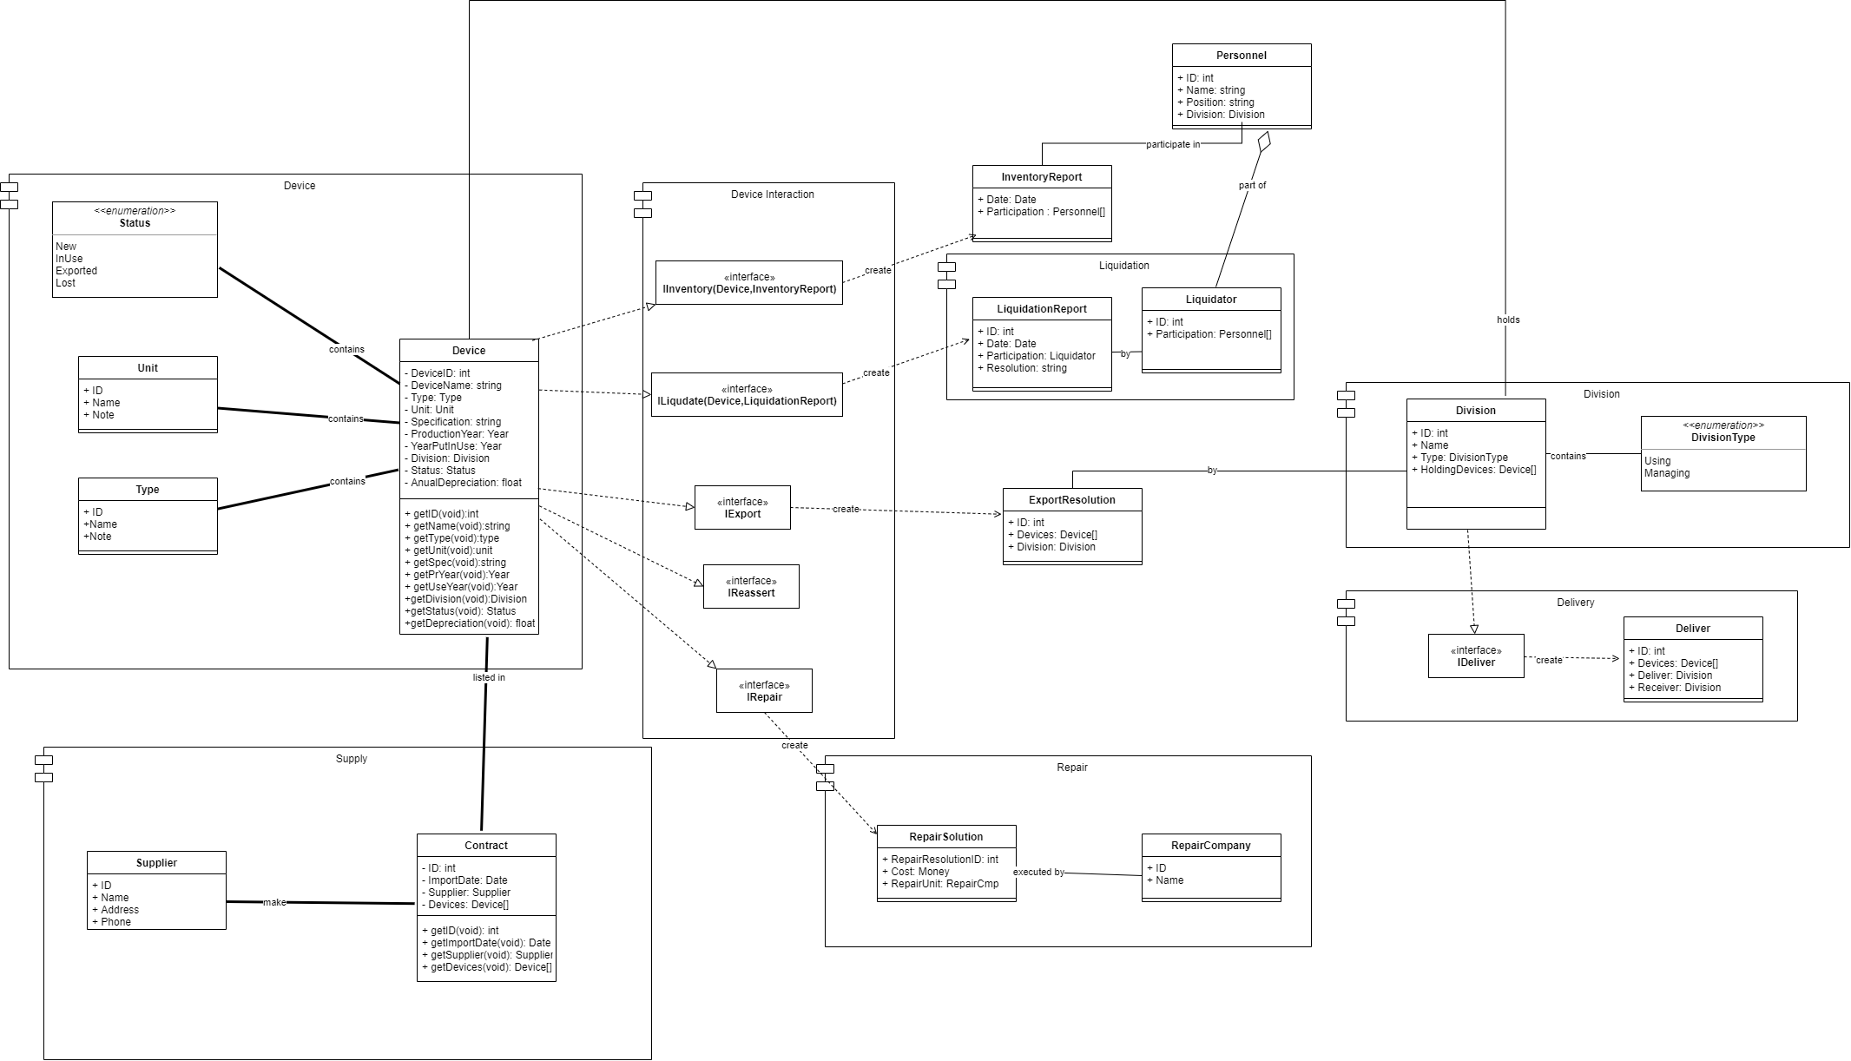

List of classes and relationships
.No | Class/Relationship | Type | Note
1 | Device/Association |  | Status/Unit/Type/Division/Contract
2 | Device/Realization |  | IInventory/Iliquidate/IExport/IReassert/IRepair
3 | IRepair/Dependency |  | RepairSolution
4 | IExport/Dependency |  | ExportResolution
5 | IIventory/Dependency |  | InventoryReport
6 | Iliquidate/Dependency |  | LiquidationReport

List of attributes
- Device:
.No | Attribute Name | Type | Constraints | Meaning/Note
1 | DeviceID | int
2 | DeviceName | string
3 | Type | Type
4 | Unit | Unit
5 | Specification | string
6 | ProductionYear | Year
7 | YearPutInUse | Year
8 | Division | Division
9 | Status | Status
10 | AnualDepreciation | float
List of main responsibilities (methods). It is necessary to specify which methods need to be re-implemented for subclasses of objects.
.No | Method Name | Constraints | Note
1 | getID()
2 | getName()
3 | getType(password)
4 | getUnit()
5 | getSpec()
6 | getPrYear()
7 | getUseYear()
8 | getDivision()
9 | getStatus()
10 | getDepreciation()
- Status
.No | Attribute Name | Type | Constraints | Meaning/Note
1 | New
2 | InUse
3 | Exported
4 | Lost
- Unit
.No | Attribute Name | Type | Constraints | Meaning/Note
1 | ID | int
2 | Name | string
3 | Note | string

.No | Attribute Name | Type | Constraints | Meaning/Note
1 | ID | int
2 | Name | string
3 | Note | string

Cohesion and coupling
- Coupling in this diagram: Data Coupling because the three modules communicate with each other by transferring data only.
- Cohesion in this diagram: Now the class diagram has been updated and it’s now functional cohension

State machine diagram (2-3 diagrams)
State machine diagram haven’t been developed yet.

